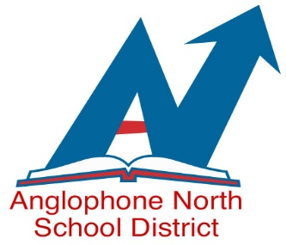
EMPLOYMENT OPPORTUNITIES
WE ARE AN EQUAL OPPORTUNITY EMPLOYER
CUPE 1253 MEMBERS

ANGLOPHONE NORTH SCHOOL DISTRICT
HOURLY SCHOOL BUS DRIVER
2024-2025 School Year
Permanent

Classification Specifications: As per attached job description.

Essential and Desirable Qualifications: As per attached.

Wage or Salary Rate: $23.70 per hour/Bus Driver (as of April 1, 2023)

Hours of Work: Hourly driver – minimum of 6.0 hours daily or the time necessary to complete the assigned duties.

Bus Route – Bus # 452 Permanent

COMP # 24-471

AM – 7:45 am Ramsay St., King St., Central St., Prince William St., Sr. Green Rd to Lord Beaverbrook Elementary
School, Campbellton Middle School and Sugarloaf Senior High School

PM - 3:00 pm Aberdeen St., Central St., King St., Ramsay St. and Prince William St. from Lord
Beaverbrook School, Campbellton Middle School and Sugarloaf Senior High

Route and shifts are subject to change to meet operational requirements.

Posting Date: November 12th, 2024

Closing Date: November 26th, 2024 at 12:00pm (Noon)

Apply To - Anglophone North School District

Email to: ASDN.Jobs@nbed.nb.ca

Please send a separate application for each position and include the competition number, your complete mailing address and phone number where you can be reached with your application.

